**Setting permission to objects and bucket level.**

In this task, we are going to create a S3 bucket by providing the required configurations such as name, region and ACLs.

1. Ensure you are in the **US East (N. Virginia) us-east-1** Region to begin creating an S3 bucket in the Amazon cloud.
2. Navigate to the **Services**menu at the top. Click on **S3** in the **Storage** section.

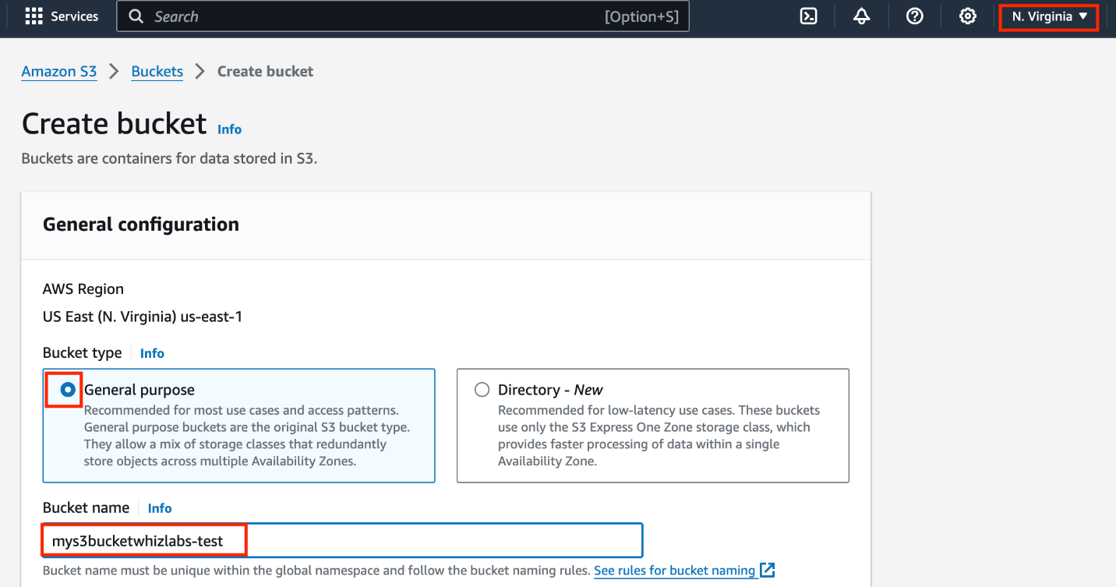

1. On the S3 Page, click on **Create bucket**and fill in the bucket details.
   * Select Bucket Type : **General purpose**
   * Bucket name: Enter**mys3bucketwhizlabs-test**
     + **Note:** S3 bucket name is globally unique, choose a name that is available.
   * For Object ownership: Select **ACLs enabled**
   * Object ownership option: Choose **Object writer**

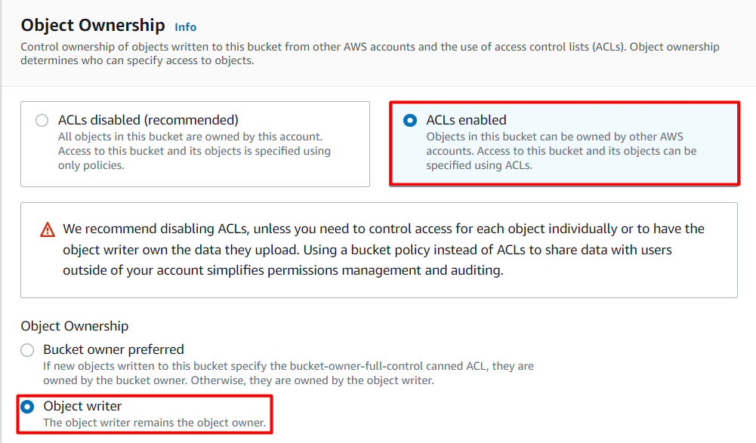

* **Note: Please select Object owner, or else it won't allow editing the bucket ACL.**
* For **Block Public Access settings for this bucket** for this bucket section,
  + Uncheck the option**, Block all public access,**
    - **Check** the **I acknowledge that the current settings might result in this bucket and the objects within becoming public** checkbox.

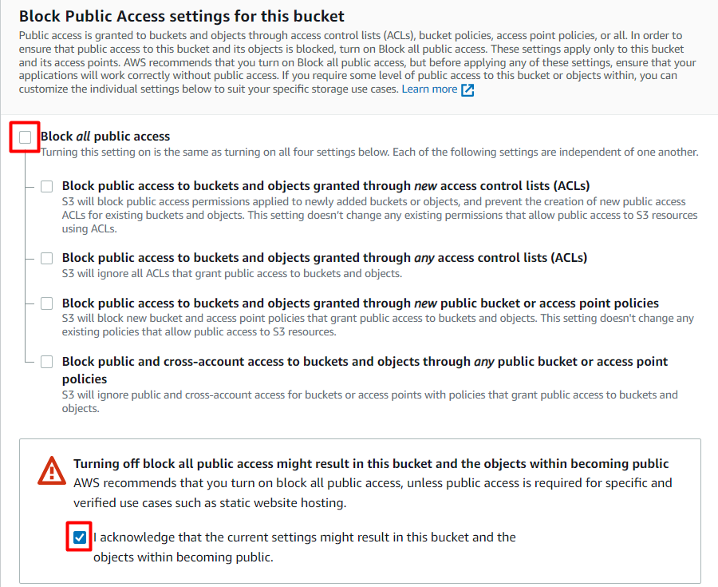

* Leave other settings as default.
* Click on **Create bucket**button.

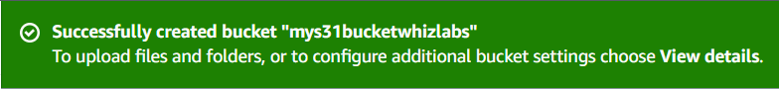

1. The S3 bucket will be created successfully.

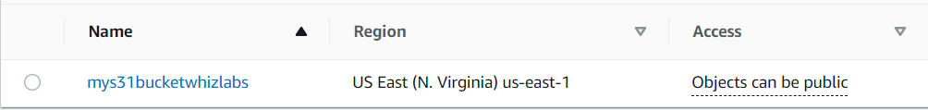

Task 3: Upload an object to S3 bucket

1. Click on your bucket name.
2. In the Overview, You can see the following message:
   * **You don't have any objects in this bucket.**

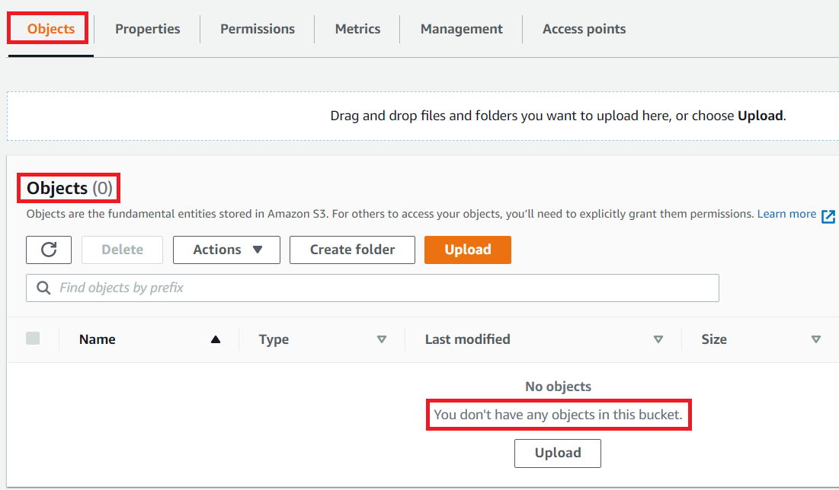

1. You can upload any image from your local machine or download the image from this [Link](https://labresources.whizlabs.com/2d53c05679d7f8b47165253d8e226165/smiley2_51_04.jpg).
2. To upload a file to our S3 bucket,
   * Click on the **Upload** button.
   * Click on **Add files**button.
   * Browse for your local image or the image we provided and select it.
   * Click on the **Upload**button.
   * You can watch the progress of the upload from within the transfer panel at the top of the screen.
   * Once your file has been uploaded, it will be displayed in the bucket.

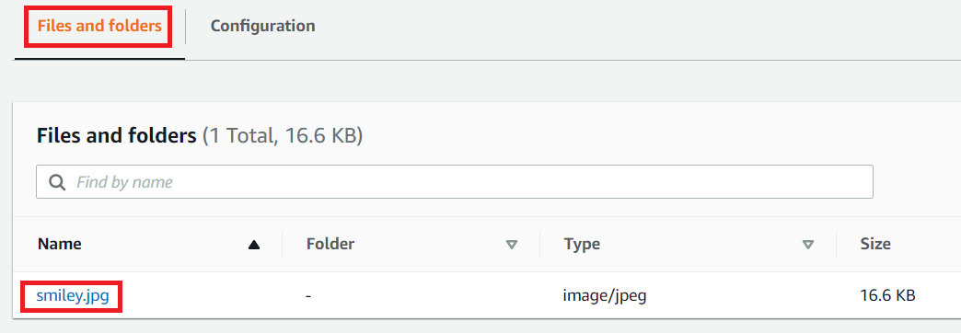

1. Now click on the **Close**button on the top right corner of the screen.

Task 4: Change Bucket Permissions

In this task, we are going to change the permissions of the bucket to make the image publicly available.

1. Under **Objects**, Click on **smiley.jpg**, You will see image details like owner, size, link, etc.
2. A URL will be listed under the **Object URL**
3. **Copy** the Object URL and **paste** it in the browser in a new tab.
   * You will see an **AccessDenied** message, which means the object is not publicly accessible.

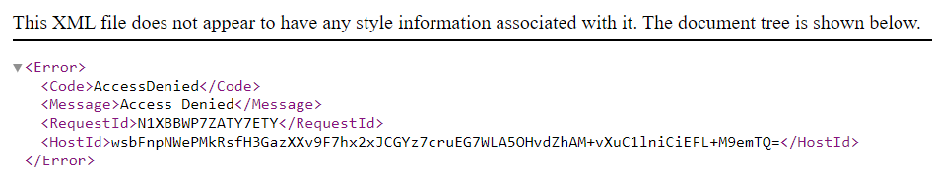

1. Go to your **smiley.jpg** object and navigate to the **Permissions** tab.

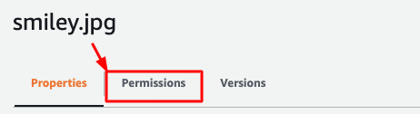

1. Now click on the **Edit**button on the right side.
2. **Note: If the Edit button is disabled, please change the bucket ownership to ACLs enabled and choose the Object writer as the owner.**
3. **Everyone (public access) :  Check** the **Read** checkbox under **Objects**column.

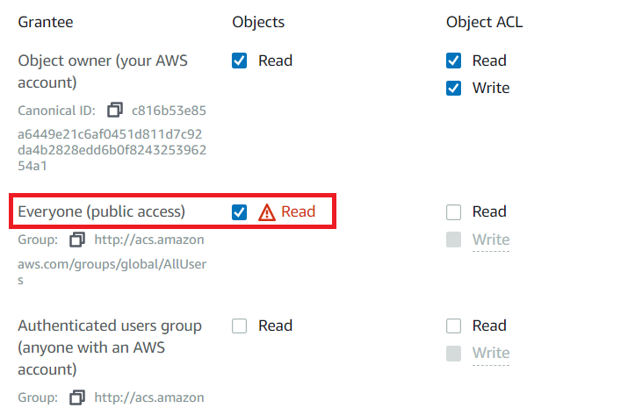

1. Now scroll a little bit below and check **I understand the effects of these changes on this object** checkbox.

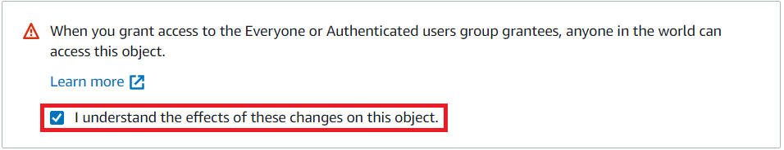

1. Now, Scroll to the bottom and click on **Save changes**button.
2. Now again **paste** the Object URL in the browser and you can see the image you have uploaded.

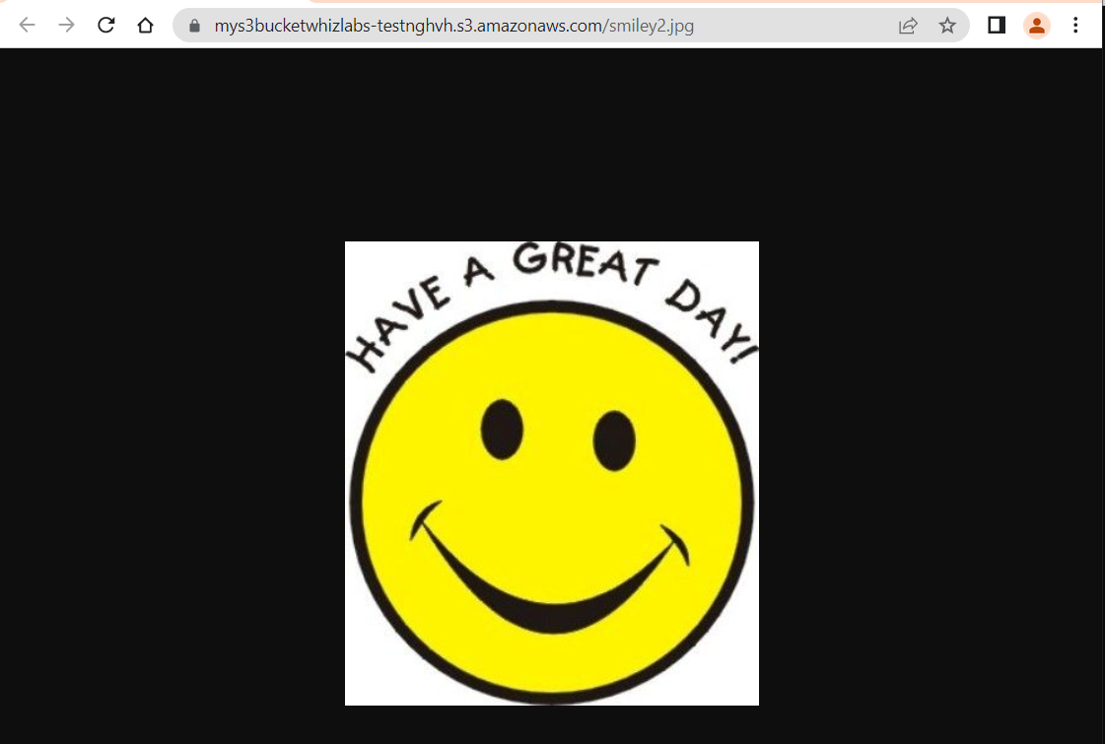

Task 5: Create a Bucket Policy

1. In the previous step, you granted read access only to a specific object. If you wish to make all objects inside a bucket available publicly, you can achieve this by creating a **Bucket policy.**
2. Go to the bucket by clicking on your bucket name - **mys3bucketwhizlabs** on the top.



1. Click the **Permissions** tab, then configure the following
   * Scroll down to **Bucket policy**, click on **Edit**button on the Right side.
   * A blank **Bucket policy editor** is displayed.
   * Copy the **ARN** of your bucket to the clipboard.
     + **arn:aws:s3:::mys3bucketwhizlabs-test**
2. Copy the entire policy, paste it into the bucket policy, and replace your bucket ARN with the ARN listed in the JSON below.

|  |
| --- |
| {  "Id": "Policy1",  "Version": "2012-10-17",  "Statement": [  {  "Sid": "Stmt1",  "Action": [  "s3:GetObject"  ],  "Effect": "Allow",  "Resource": "replace-this-string-with-your-bucket-arn/*",  "Principal": "*"  }  ]  } |



* Click on **Save changes**button.

Task 6: Test Public Access

1. Go to the bucket and upload another image; download the Whizlabs logo image from [Download Me](https://labresources.whizlabs.com/2d53c05679d7f8b47165253d8e226165/whizlabs_logo_57_09.png)
   * Click on the **Upload** button.
   * Click on **Add files**button.
   * Browse for the downloaded image we provided and select it.
   * Click on the **Upload** button.
2. Once the image is uploaded successfully, click on the object name (Image name) , copy the Object URL, and open it in a browser.
   * https://whizlabsresources.s3.amazonaws.com/whizlabs-logo.png

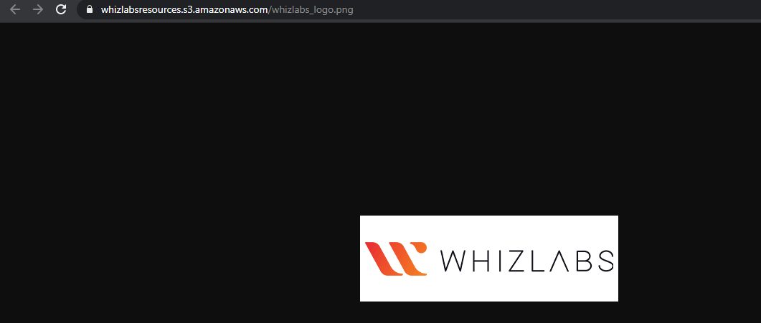

1. You can see your image loaded successfully and is publicly accessible.